**DATAWAREHOUSE ASSIGNMENT – 1**

1. **Design a Data Warehouse for IPL Cricket Tournament (Asked in Flipkart Interview for Senior Data Engineer role)**

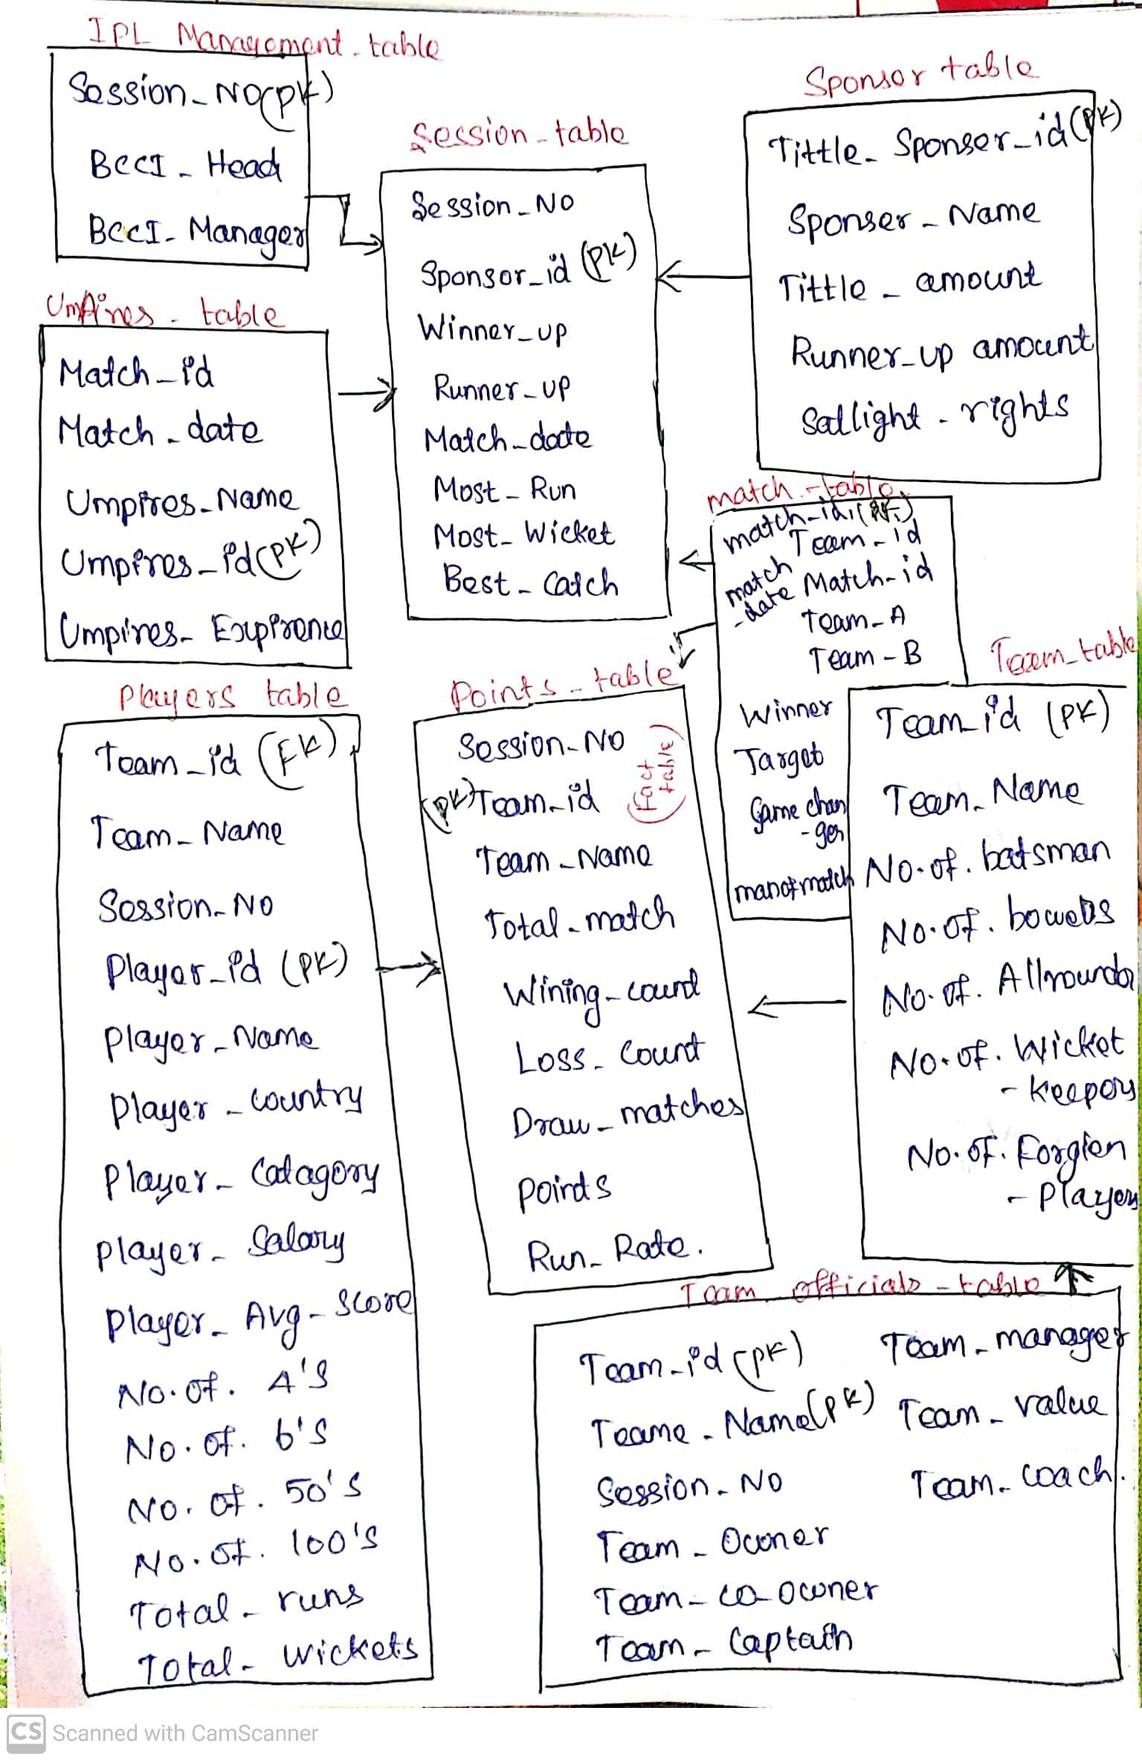

**Fact Table -** Point Table

**Dim Table –** Players Table, Team_official_table, Team_table, Match_table, Session_table, Umpires_table, Sponsers_table, session_management_table.

1. **Design a Data Warehouse for Food delivery app like Swiggy, Zomato (Asked in Grab for Data Engineer role)**

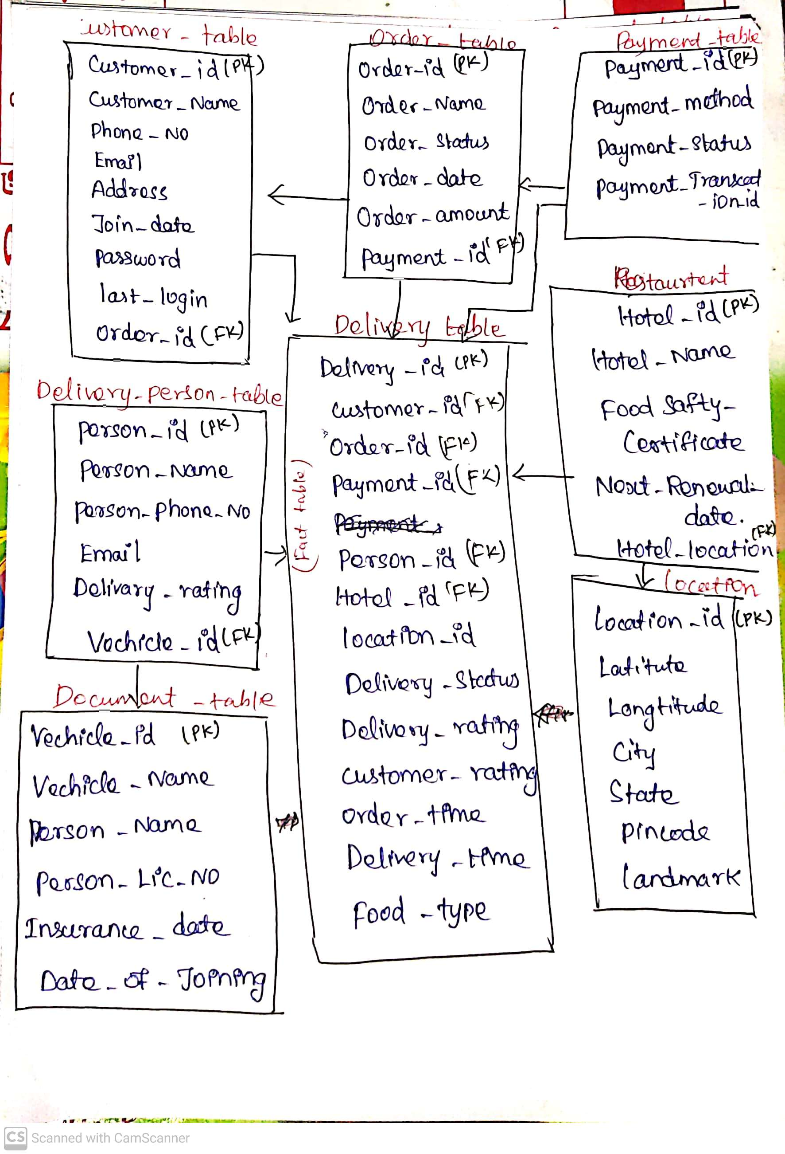

**Fact Table –** Delivery_Table

**Dim Table –** Customer_table, Order_table, Payment_table, Delivery_person_table, Document_table, Restaurent_table, Location_table.

1. **Design a Data Warehouse for cab ride service like Uber, Lyft (Asked in Google for Data Engineer role)**

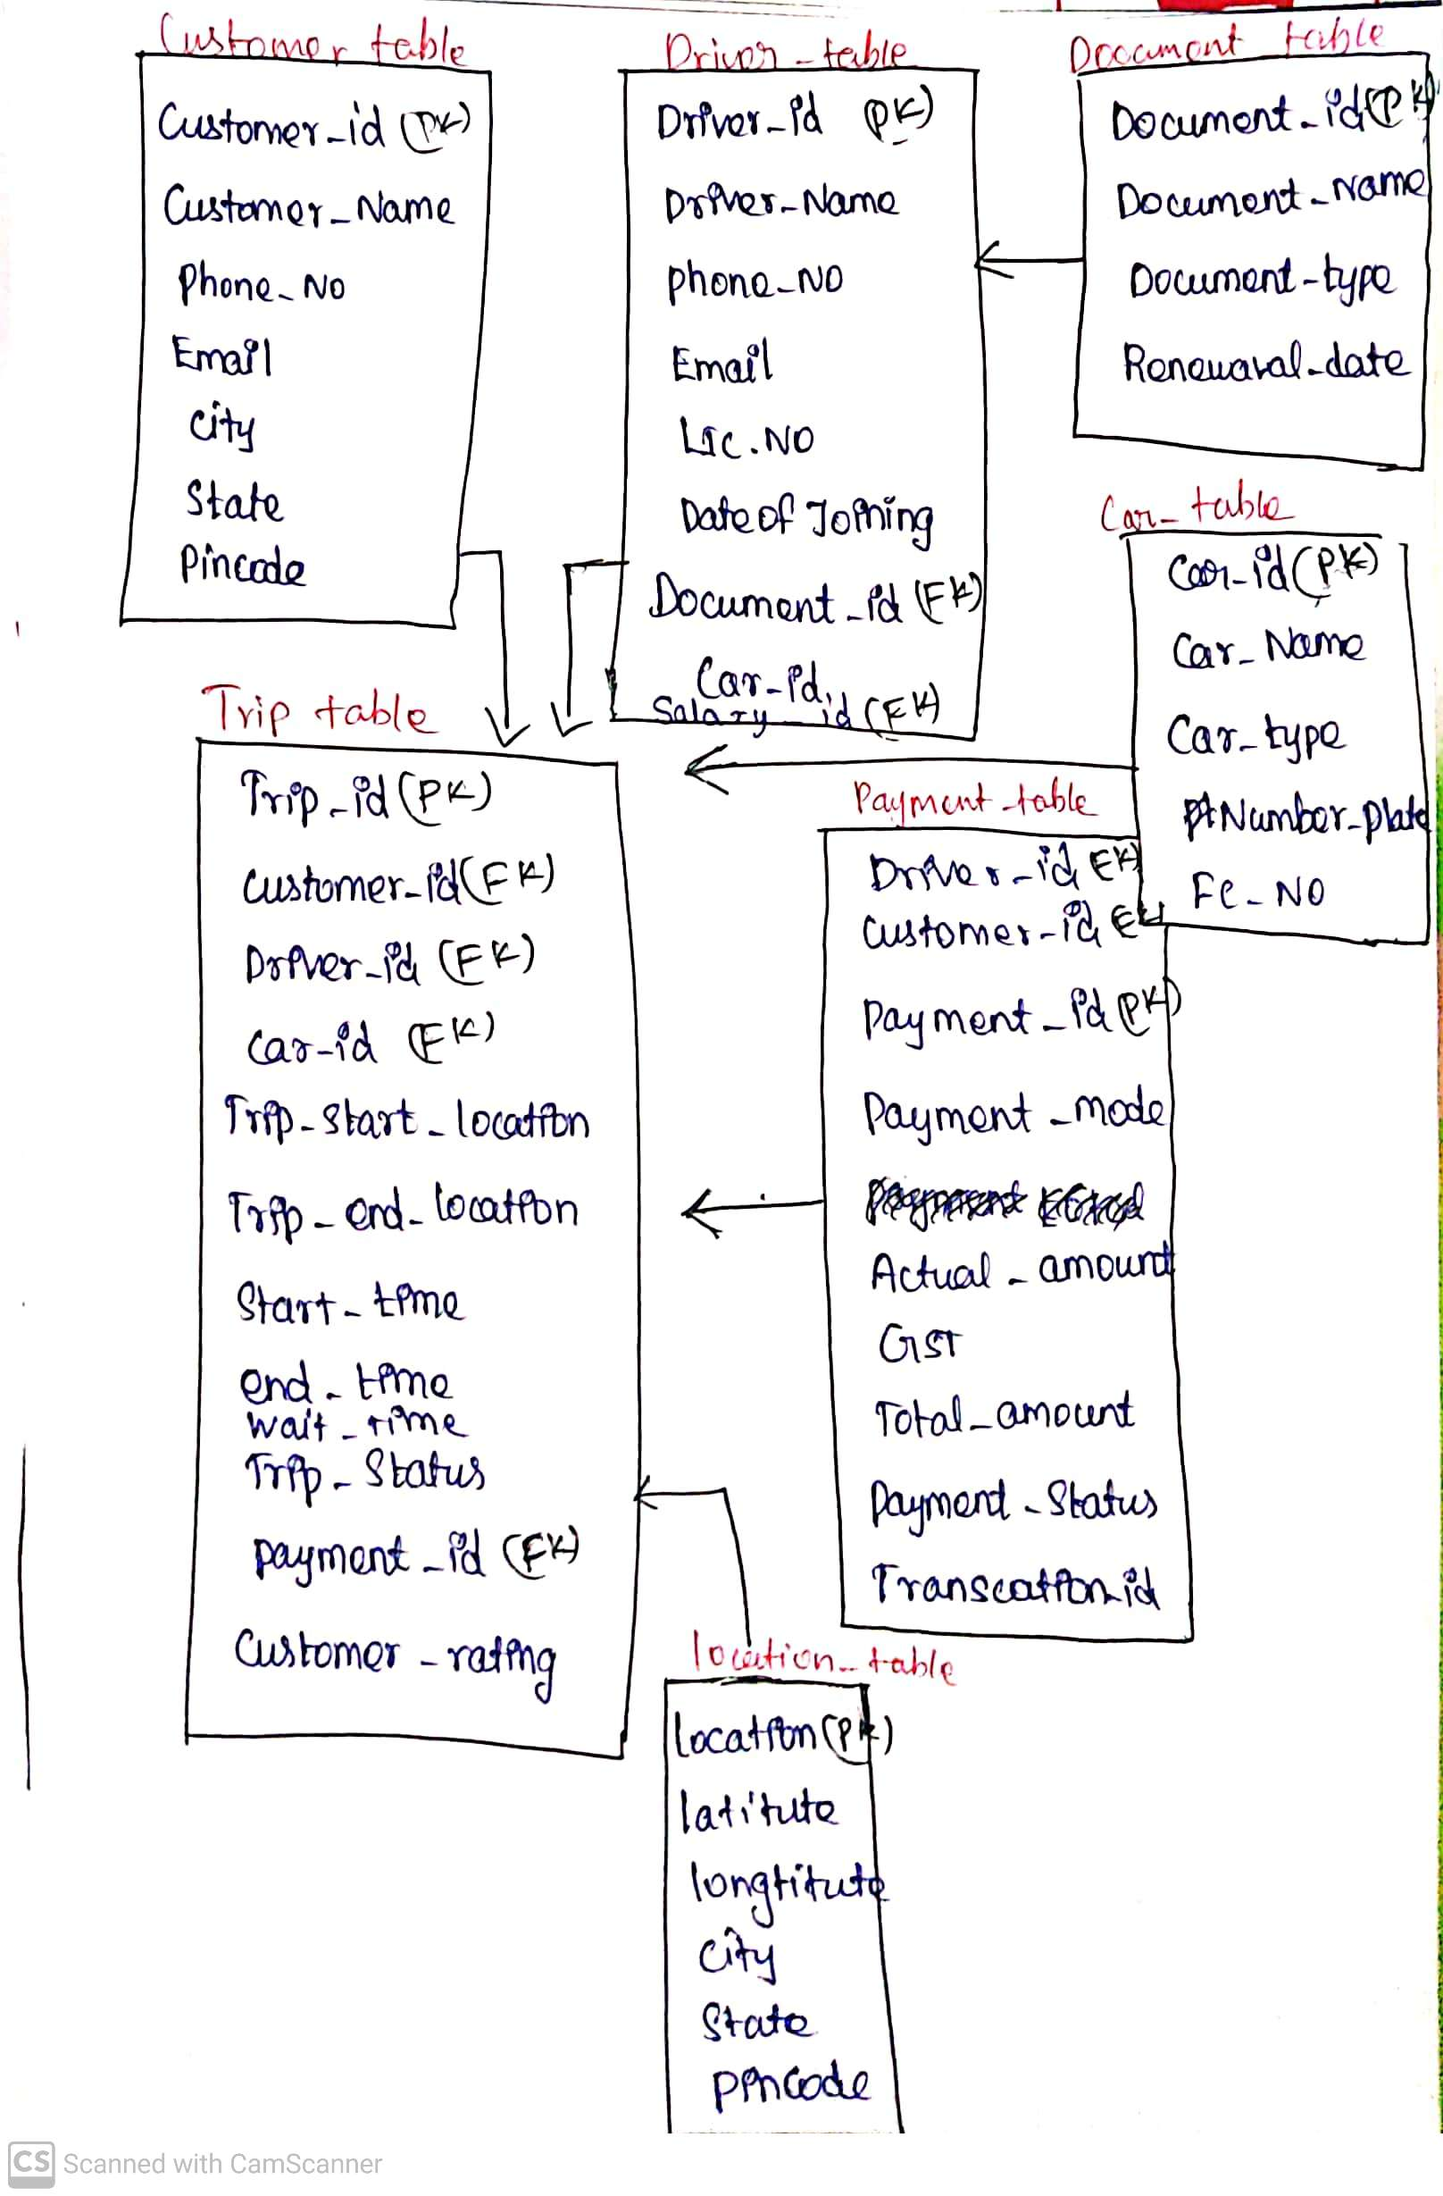

**Fact Table –** Trip_Table

**Dim Table –** Customer_table, Driver_table, Payment_table, Car_table, Document_table, Location_table.

1. **Design a Data Warehouse for Restaurent table booking app like Dineout (Asked in McKinsey for Consultant Data Engineer role)**

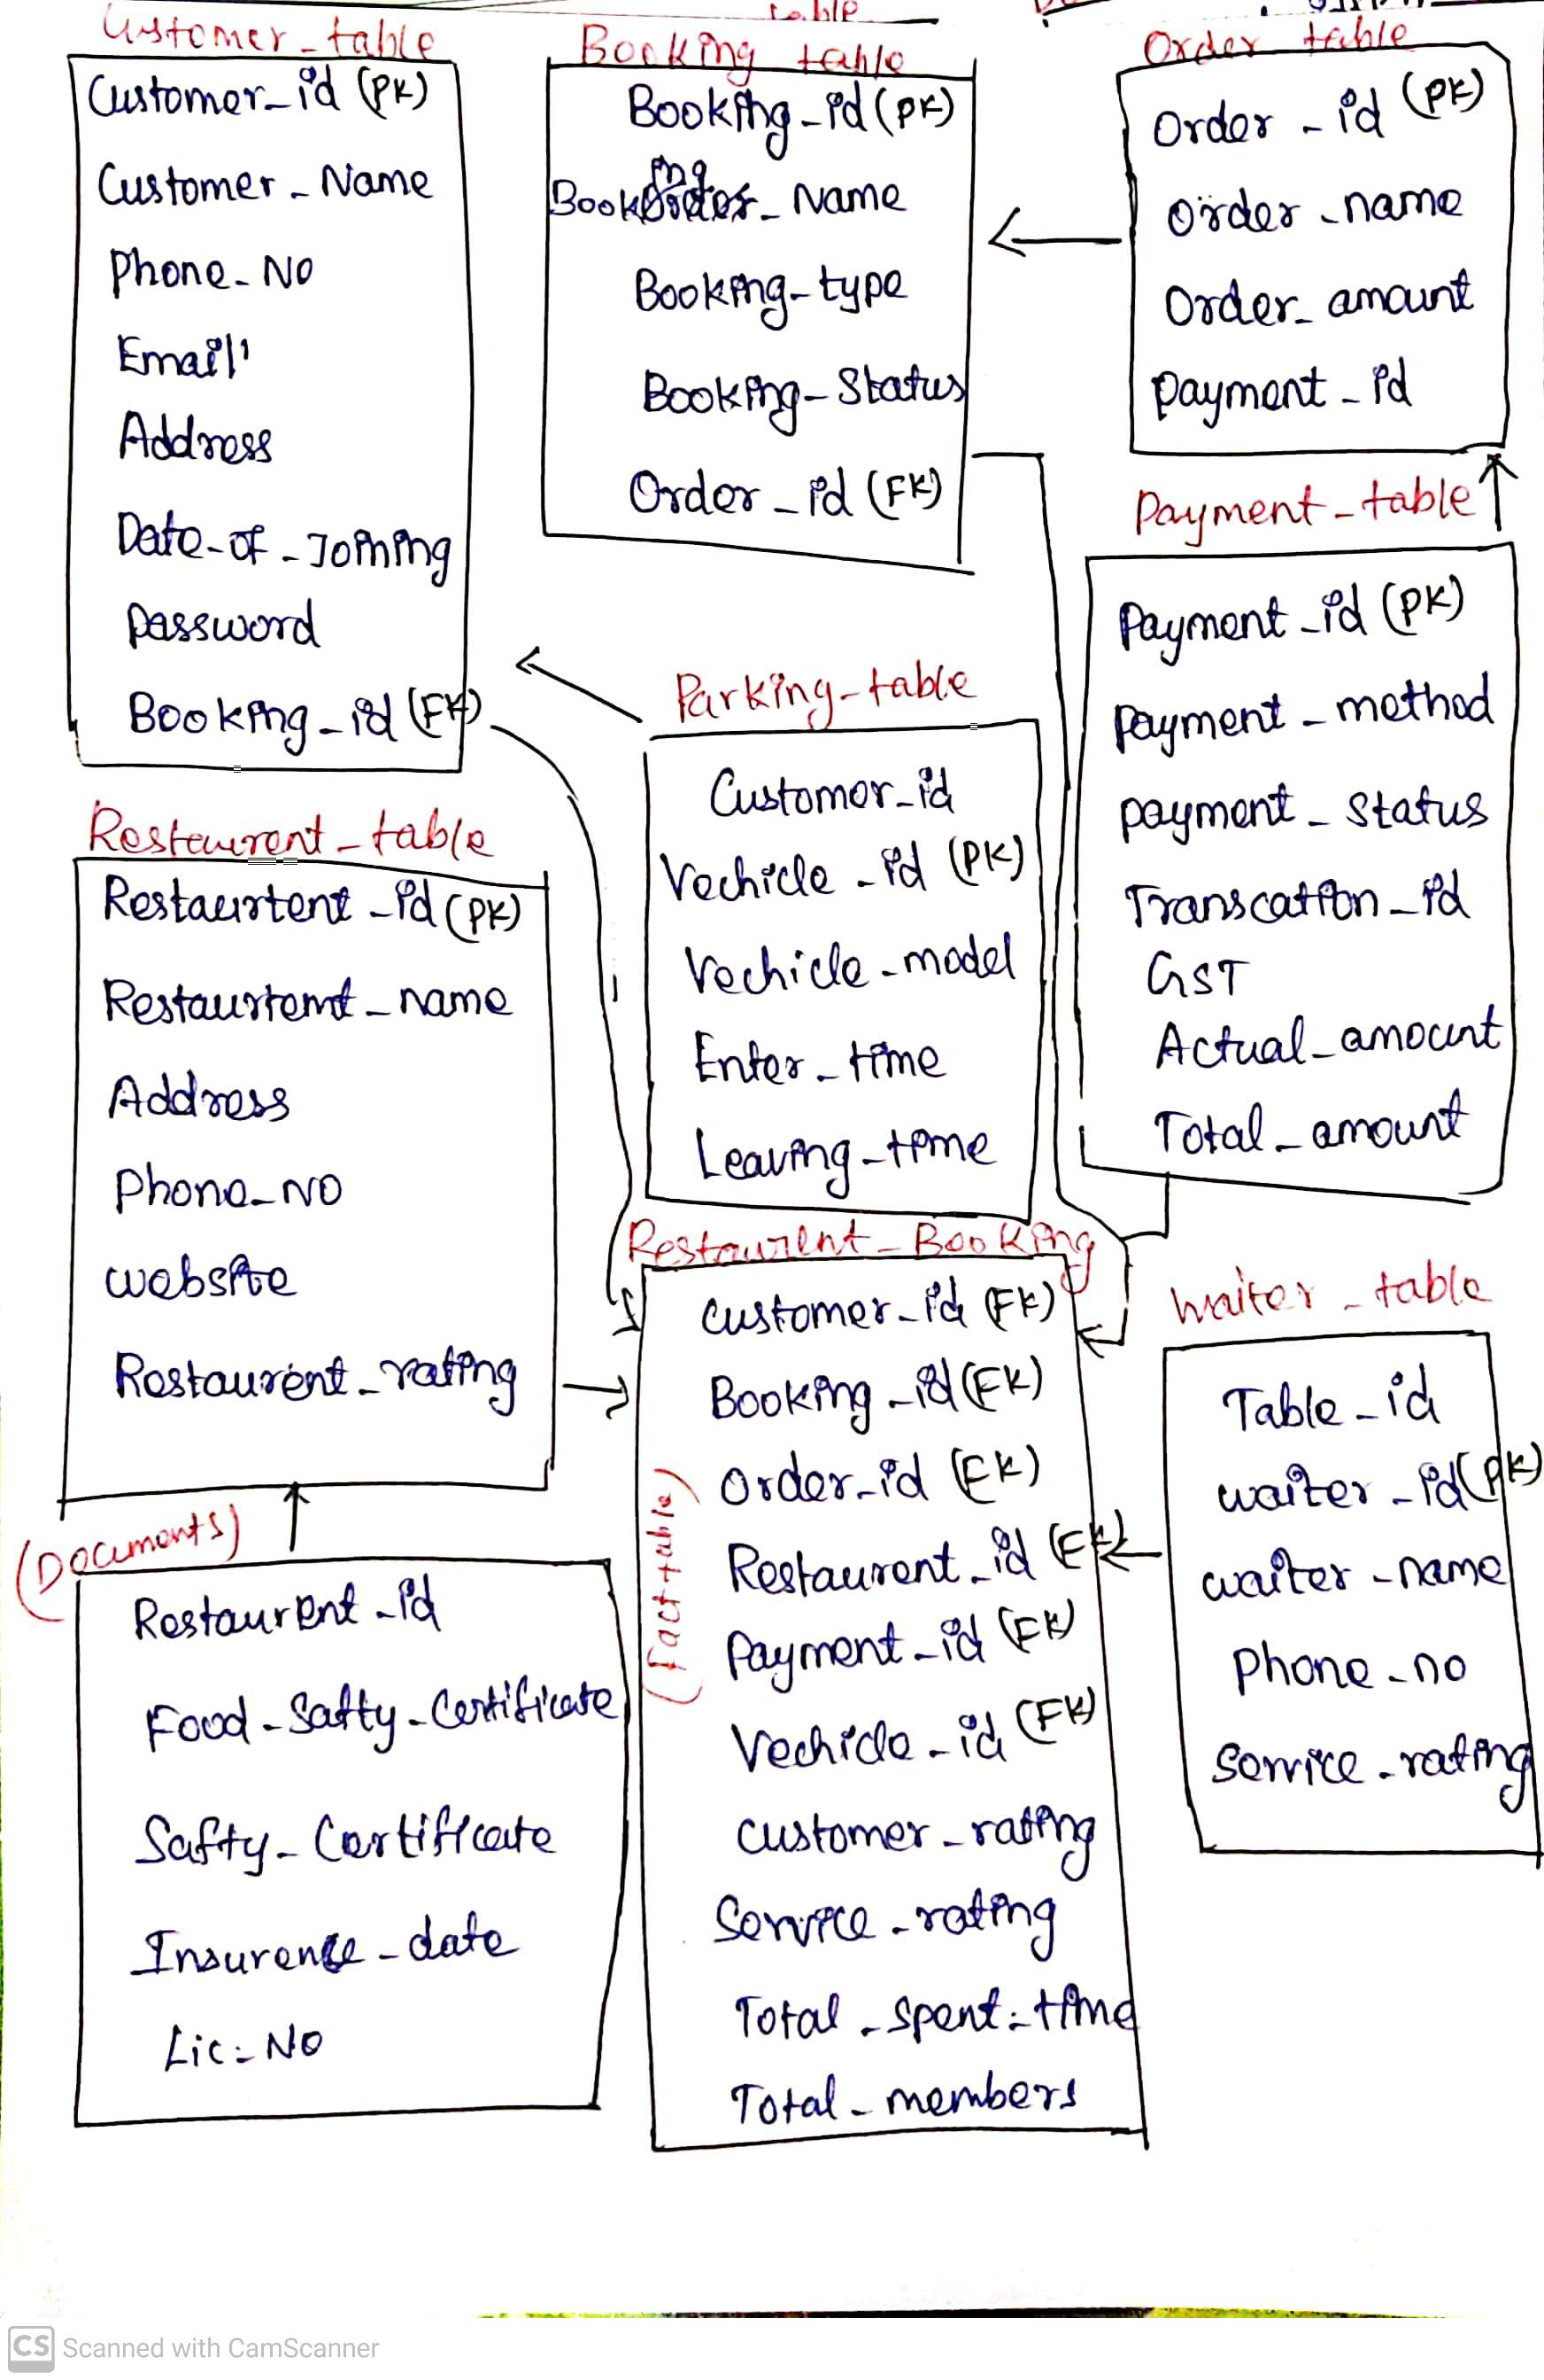

**Fact Table –** Restaurent_booking_Table

**Dim Table –** Customer_table, Booking_table, Order_table,Payment_table, Restaurent_table, Document_table, Waiter_table, Location_table, Parking_table.

1. **Design a Data Warehouse for Covid Vaccination Application (Asked in Livsapce for Data Engineer role)**

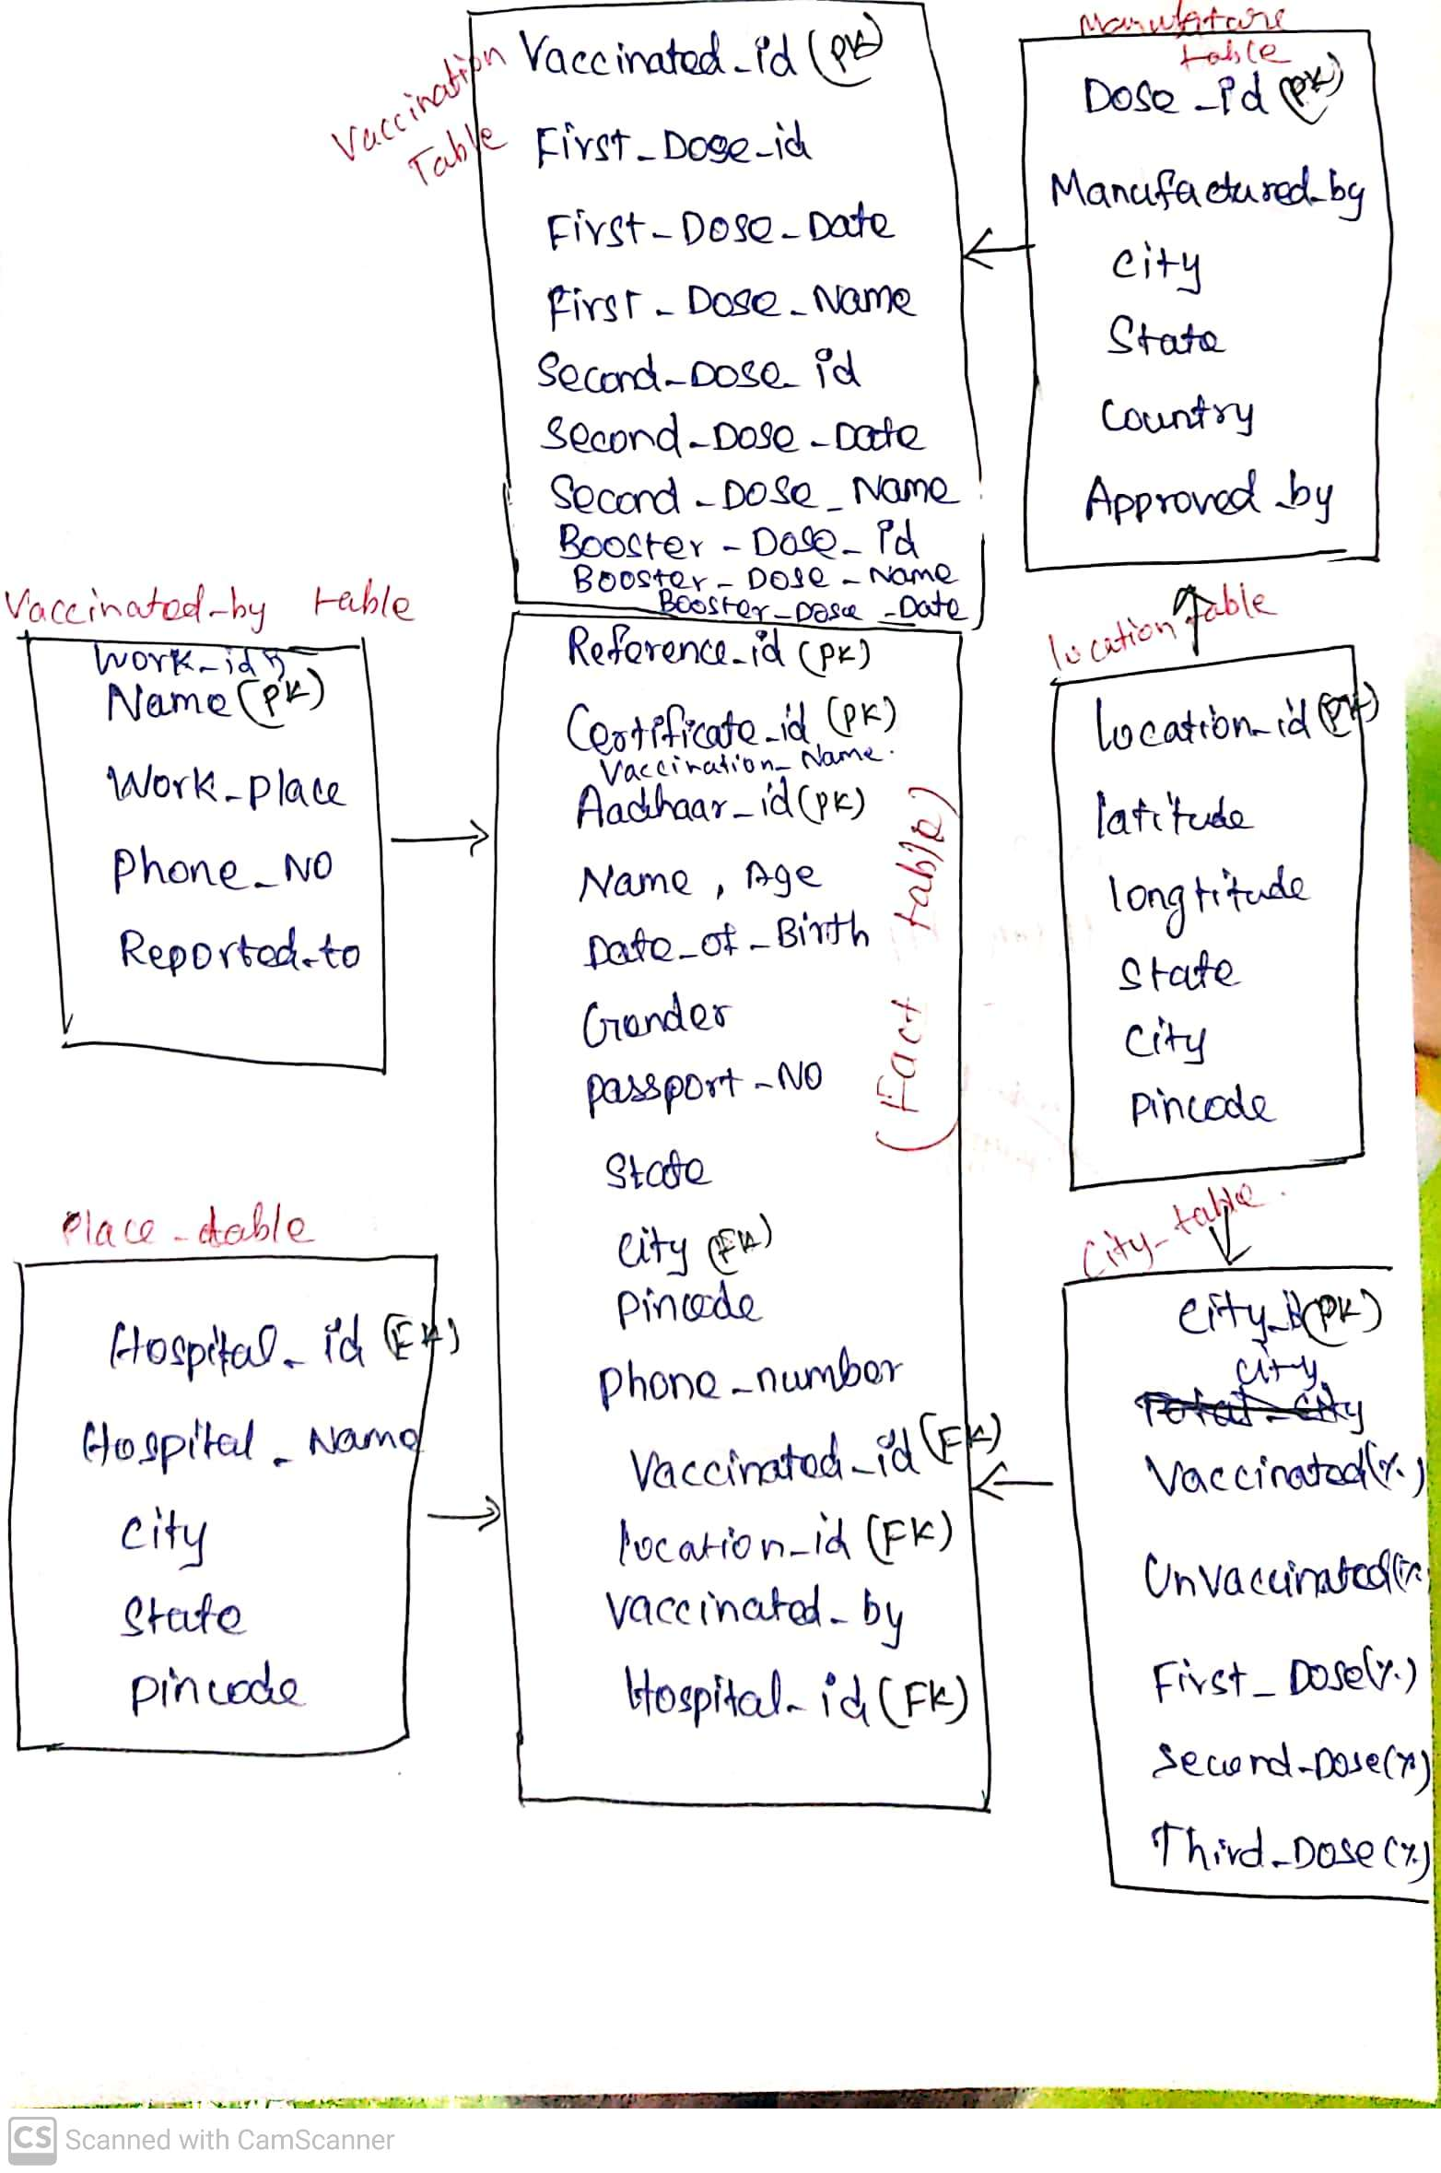

**Fact Table –** Covid_data_Table

**Dim Table –** Vaccination_table, Vaccinated_by_table, Manufature_by_table, Location_table, City_table, Vaccinated_place_table, Dose_table.